**Descriptive Writing (User manual/How to guide/Training)**

**DMIT 2000: Advanced Communications - Section OA06**

By Seonhye Yoon

**How to make the perfect walnut tart**

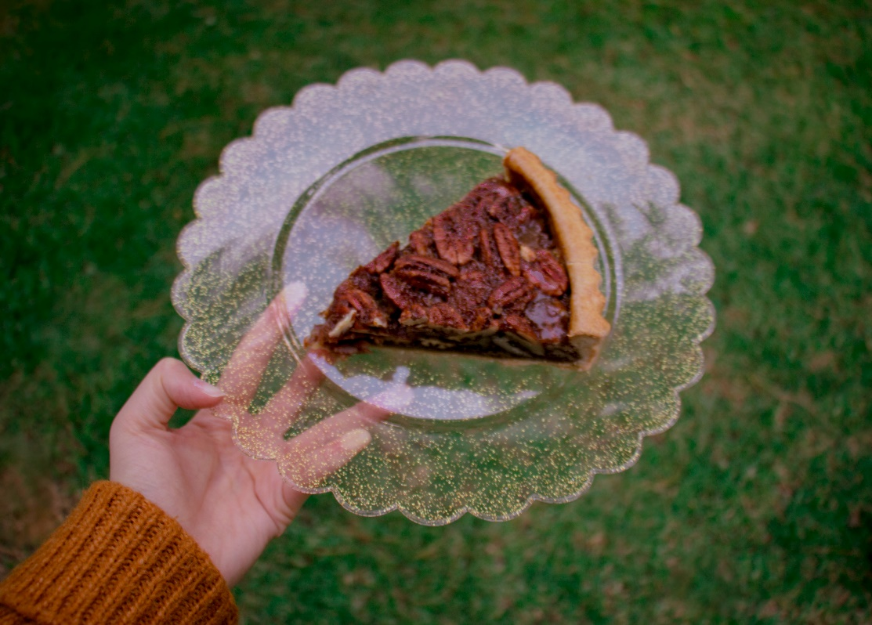 (nikohoshi, 2020)

Recently, in the Covid-19 Pandemic, more and more people are looking for hobbies that can be done at home, and more people are baking at home. This paper intends to help beginner home-bakers make the perfect tart. I chose walnut tart because its ingredient is easy-to-get, and people can easily consume it in various ways without making tarts.

Home-bakers must pay attention to safety before making the dessert in earnest. Watch out for burns. Because the oven maintains a high temperature of about 180 degrees Celsius, people must pay attention when putting the dessert in and out of the oven and touching the pan or food right taken out of the oven. If possible, purchase oven mitts. If there is no oven mitt, wrap it with a dishcloth and take out the pan. The most important thing is not to get hurt.

Tarts may seem like desserts that are difficult to make, but home-bakers can make the tart successfully if they are careful with just a few precautions. Then, what should home-bakers avoid when making tarts? The most important thing to be careful about is the temperature of the ingredients and the oven. The tart crust should be cold temperature before baking in the oven, and the filling should not be too hot. (J’adore, 2018) It affects the texture of the pie a lot. Home-bakers can get a crispier pie shell when the pie dough is cold. It is also essential the proper temperature of the oven. If the temperature is too high, the pie may burn, or the pie may not cook if the temperature is low. Moreover, please do not forget to preheat the oven. If home-bakers forget preheating, they can get a different result than they want. Be careful when preheating the oven because the temperature drops while opening and closing the oven, so preheating should be performed at 10-20 degrees higher than the baking temperature. Please keep this in mind; home-bakers can successfully make walnut tarts without failure.

For this paper, the recipes that I will refer to are from channel J’adore on YouTube. The diameter of the tart shell is 20cm, and the height is 2cm.

The steps to make walnut tarts can be seen in three main steps:

1. Activating walnuts (nuts)
2. Making pie shell
3. Making pie feeling

Activate walnuts before making tarts. Nuts contain a phytic acid, which prevents our bodies from absorbing the nutrients and minerals they contain. Therefore, it is recommended to remove phytic acid before eating nuts. (Bridgets Healthy Kitchen, 2014) Add water to soak walnuts. Soak in water for at least 5 to 8 hours. (Honest to Goodness, 2018) After that, throw it away along with the water, and put it on a sieve to drain the water. Then, spread it in a single layer in a baking pan (or a pan that can be used in an oven) and bake it below 65 Celsius degrees for about an hour.

Now it is time to make the tart shell. First, measure the ingredients needed for tart crust: 105g of flour, 42g of sugar, 50g of room temperature butter, 1g of salt, 21g of eggs at room temperature. Whip the room temperature butter well. Add sugar powder and salt to the butter and mix well. As the sugar powder melts, the butter becomes softer. If mixed well, divide the eggs into two and mix them quickly. Butter and eggs must be at room temperature to mix well without separation, so make sure to use room temperature butter and eggs. If the butter mixture and the eggs are mixed well, add the flour and mix well using a spatula to form a lump. (J’adore, 2019) Put the lumpy tart dough in a plastic bag or wrap it well and put it in the refrigerator. If the tart dough is not cool, it sticks to the rolling pin, and when it is cold, the baked one is crispier, so put it in the refrigerator and rest until it gets cold. When the dough gets cold, please take out the dough from refrigerator and roll it out even. Push in various directions to a size that can wrap the tart pan 20cm in diameter and 2cm in height. Now, place the dough in the center of the tart pan and crumple the dough to remove empty spots. It is okay if it is torn or punctured. Take out some of the remaining dough and fill it up. Then, stick the tart dough to the side of the mould so that there are no empty spots. Roll the rolling pin on the top of the tart pan to neatly remove the dough. (J’adore, 2019) Put parchment paper on the dough and place pie weights on it. If home-bakers do not have pie weights, they can place pie weights to anything that fits the diameter of the tart pan so that the dough does not swell. Then, bake it in the pre-heated oven at 170 degrees for 15 minutes, remove the pie weights, and bake it for about 10 minutes additionally.

After making the tart shell, let us make walnut pie filling. Measure the ingredients for pie filling first: 76g of eggs, 30g of honey, 40g of starch syrup (substitute brown honey), 50g of muscovado (substitute brown sugar), 50g of butter, 2g of vanilla extract (can be skipped), 200g of activated walnuts. Add honey, starch syrup, muscovado, vanilla extract, and salt to the pot. Set the heat to medium and heat while stirring until ingredients boil overall. After cooling to a warm level, add eggs to the pie filling mixture and mix well with a whisk. If home-bakers add an egg when the pie filling is still hot, the egg can be cooked. Therefore, make sure to cool down the filling until it reaches a temperature of about body temperature and add eggs. Fill the tart crust with walnuts as possible as many. Please be careful not to overflow with pie filling and pour it as high as the tart shell. Bake in an oven preheated to 160 degrees for 40 to 45 minutes. (J’adore, 2019) Do not forget to be careful of your hands and arms when you put the pie in the oven!

Cool it down well at room temperature after baking the walnut pie. Home-bakers can eat the cold pie right away, but it is more delicious if they harden it in the freezer for about 10 to 20 minutes. Please keep the leftover pie refrigerated. If you plan to store it for more than a day, I recommend you seal it and keep it frozen. If left at room temperature, it can get soggy, and it is more delicious to eat cold. (J’adore, 2019)

**References**

Bridgets Healthy Kitchen. (2014, February 17). *How To Activate Your Nuts & Why It’s Important For Your Cooking || FOODIE HACK*. YouTube. https://www.youtube.com/watch?v=NpKdRdx-N5w

Garifullina, D. (2020, February 5). *Pie dough* [Photograph]. Unsplash. https://unsplash.com/photos/_HeQMwIcgQ0

Honest to Goodness. (2018, December 12). *How to Activate Nuts [Quick Guide]*. https://www.goodness.com.au/blog/how-to-activate-nuts-quick-guide/

J’adore. (2018, October 3). *[Eng Sub] Amazing pecan pie│J’adore*. YouTube. https://www.youtube.com/watch?v=Py1W9nCnVqw

J’adore. (2019, January 23). *Three ways of making Tart Shell｜J’adore*. YouTube. https://www.youtube.com/watch?v=Rw-T1PTBdQ8&t=700s

Nikohoshi. (2020, June 10). *Pecan pie* [Photography]. https://unsplash.com/photos/CAlyrGdn8fA